York University June 2022

PhD Preliminary Examination

PhD Cognate Area 2

**A review of environmental heterogeneity in ecology.**

Nargol Ghazian

Submitted to the Faculty of Graduate Studies in Partial Fulfillment of the Requirements for the Degree of Doctor of Philosophy (PhD)

Dr. Suzanne MacDonald (Supervisor)

Dr. Christopher J. Lortie (Co-Supervisor)

Dr. Laura McKinnon (Advisor)

Dr. Bridget Stutchbury (Graduate Program Director)

1. **Introduction**

***Historical background***

One of the main goals of ecology is understanding the effects of environmental heterogeneity on diversity, disturbance, ecosystem services, and ecosystem resilience. Ecosystems are evidently heterogeneous; however, throughout much of history, heterogeneity was looked upon as an unnecessary complication, and homogeneity was assumed for the sake of convenience and simplicity (Cadenasso and Pickett 1995). Even when considered, the term ‘heterogeneity’ is rarely defined leading to confusion and ambiguity (Tamme et al. 2010). Environmental heterogeneity (EH) is broadly defined as, “non-uniformities in physical and ecological landscape characteristics” (Dronova 2017). Environmental heterogeneity can influence biodiversity (Stein et al. 2015; Mace, Norris, and Fitter 2012), agricultural productivity (Kremen and Miles 2012), and resilience of natural and human ecosystem stressors (Levine et al. 2016; T. H. Oliver et al. 2015). Spatial variation and patterns in nature were a concern of early ecologists but they lacked the long history of empirical studies and the conceptual and mathematical models used in today’s studies (Lovett 2005). Early notions of environmental heterogeneity were discussed embedded in the discourse concerning ecological succession such as when Cowles (1899) attempted to explain spatial patterns and temporal change in vegetation as the result of interactions between plants, soil, and the physical environment (Cowles 1899). The greatest debate was about the factors that cause spatial patterns in vegetation that took place between Gleason and Clement. Gleason (1926) argued that Clement’s model (Clements 1936) of describing vegetation patterns as set associations (predictable species composition in a community), for example, oak-maple association, assumed too much homogeneity and instead offered the ‘individualistic concept of ecology’ where the real diversity of vegetation depends completely on “the phenomena of the individual” meaning each individual present in the ecosystem. Additionally, Gleason argued that associations of species with the surrounding species and environment are random (McIntosh 1975). Another area where EH was historically implicitly discussed was the concept of niche differentiation focusing on the spatial differences in species distributions such as in Grinnel’s (1917) study of bird distributions in California. Swanson and Sparked (Magnuson 1990) argued that “significance of research results is difficult to interpret if site’s context in space is not understood.” They termed this the ‘invisible place’ where misleading conclusions of short-term studies can be made. Today, EH is a term that encompasses spatial environmental heterogeneity such as non-uniform land cover, vegetation, climate, soil and topography and temporal variability such as short-term seasonality and long-term transitions of successional vegetation and land cover (Dronova 2017). Environmental heterogeneity can be divided into biotic EH and abiotic EH (Stein, Gerstner, and Kreft 2014). Much of the present efforts focus on developing methods and conceptual models that make it easier to incorporate the concept of heterogeneity into the ecological research. (Lovett 2005). Ecologist have begun to appreciate the importance of patch dynamics and disturbances and it is thus clear that assumption of homogeneity in spatial and temporal is simply unrealistic. The concern for ecological sustainability is one the greatest challenges today. Incorporating a heterogeneous paradigm to sustainable environmental goods and services will likely be key in the future.

***A closer look at key definitions of environmental heterogeneity***

Environmental heterogeneity has been discussed under a wide umbrella of terms and ecological interpretations of heterogeneity are extremely broad. In recent reviews, it was shown that are numerous terms used to denote heterogeneity, which are undefined or have conflicting underlying concepts (Stein and Kreft 2015). Some distinguish heterogeneity as the horizontal habitat variation as opposed to the complexity in the vertical component (Grelle 2003); though, others argue that spatial and temporal heterogeneity can have more than two dimensions (Kolasa and Rollo 1991). Others simply defined variability and complexity as constituents of heterogeneity (Li and Reynolds 1995). Other terms used in the literature include: altitudinal variation, elevational or environmental variability, habitat, landscape, or vegetation complexity/diversity/heterogeneity/structure, spatial heterogeneity/variability, and structural complexity (Stein, Gerstner, and Kreft 2014). Variability in definitions may obscure the importance of EH in ecology. Thus in this review, I simply define environmental heterogeneity as the variation/complexity in spatial and temporal components, and/or structure in the environment, regardless of the three dimension direction. EH can be divided into two broad categories: temporal heterogeneity and spatial heterogeneity. Temporal heterogeneity refers to variability in environmental conditions including stressors and climatic fluctuations through different scales of time (Menge and Sutherland 1976). Spatial heterogeneity on the other hand has to do with heterogeneity in the physical structure of the ecosystem and spatial dynamics, including fluxes of organisms, materials, and energy within the landscape (Cadenasso and Pickett 1995). For the purposes of this review, I will mainly consider the concept of spatial heterogeneity. EH can be divided into five main subject areas including two biotic components land cover, vegetation, and three abiotic components climate, soil, and topography (Stein and Kreft 2015; Stein, Gerstner, and Kreft 2014) (Table 1). Given the variability of terms in the published literature and the used of synonymous terminology, it is important the studies define terms well to better aid the readers in understanding the concept of heterogeneity, both in empirical studies and future syntheses. In the following sections we will describe each EH subject area in detail, as well discussing the role of disturbance on heterogeneity, heterogeneity on disturbance, heterogeneity and organismal interaction, and the future of the field given the immense anthropogenic pressures of today’s ever-changing world.

**Table 1.** Definitions table for keywords related to environmental heterogeneity.

|  |  |
| --- | --- |
| Keyword | Definition |
| *Environmental Heterogeneity (EH)* | Term that encompasses spatial environmental heterogeneity such as non-uniform land cover, vegetation, climate, soil and topography and temporal variability such as short-term seasonality and long-term transitions of successional vegetation and land cover . |
| *Temporal heterogeneity* | Variability in environmental conditions including stressors and climatic fluctuations through different scales of time. |
| *Spatial heterogeneity* | Variation in the physical structure of the ecosystem and spatial dynamics, including fluxes of organisms, materials, and energy within the landscape. |
| *Land cover EH* | Heterogeneity between two habitats in terms of complexity and configuration between patches. Focuses on habitat and vegetation types. |
| *Vegetation EH* | Heterogeneity in plant diversity and vegetation structure such as canopy and foliage height. |
| *Climatic EH* | Heterogeneity in micro or macroclimatic conditions. |
| *Soil EH* | Heterogeneity in soil nutrients, acidity, or type. |
| *Topographic EH* | Most often discussed in terms of elevation range, this is the heterogeneity that incorporates micro topographic structure and large-scale relief. |

1. **Drivers of Environmental Heterogeneity**

***Land Cover EH***

Two major components of landscape is composition and spatial configuration. Composition refers to what and how much is present of each habitat or cover type whilst configuration refers to a specific arrangement of spatial elements (Turner and Gardner 2015). Sometimes spatial structure or patch structure is used in lieu of configuration (Forman 1995). A patch can be defined as a surface area that differs from its surroundings in nature or appearance (Forman 1995). Composition can be defined using the number of land cover type continuity across the landscape (Turner and Gardner 2015), such as forest or grass, and configuration and configuration can be defined using edge density or fractal dimension (Stein and Kreft 2015). Edge density is a measure calculated by dividing the length of particular edge class type by the estimated class area (Ramezani et al. 2010). Fractal dimension is another measure calculated using the patch area to perimeter ratio with an incorporation of patch length/diameter (Imre and Bogaert 2004). Landform can be identified on the basis of three characteristics: 1) relative amount of gentle sloping (<8%) land, 2) where and how much of the gentle slope lands (upper or lower portion of the slope), and 3) local topographic relief (Bailey 2009). Number three is more related to topographic EH and will be further discussed in that section. Land cover or landform can affect the ecosystem patterns and processes in different ways (Swanson, Wondzell, and Grant 1992). For example, the elevation, aspect, parent material, and slope of landform affects ground temperature, moisture, nutrients, and other materials available within the site, which inherently affects the type of vegetation that grows there and its distribution across the landscape. Landforms can affects wind patterns and thus the dispersal of seeds (Dixon, Turner, and Jin 2002), dictating what type of vegetation grows where. Furthermore, they can affect the frequency and spatial pattern of natural disturbances such as fire, wind or grazing (Turner and Gardner 2015), as well as influencing the transport of organic and inorganic materials around the landscape (Reiners and Driese 2003). Thus, land cover EH is the result of landforms and cover types, both which have various effects on vegetation and biochemical processes of the given area.

***Vegetation EH***

Vegetation is a widely-studied aspect of heterogeneity because the type of vegetation can directly affect the local species composition and abundance. Vegetation heterogeneity is associated with diversity in resources, shelter and roosting, and breeding and oviposition sites (Tews et al. 2004; Kissling, Rahbek, and Böhning-Gaese 2007). However, vegetation EH may also negatively impact animal diversity, such as insects, when the vegetation is dense; hence, increasing the required energy expenditure needed to move across the habitat, or the when taxa is more adapted to the open (Humphrey et al. 1999; Lassau and Hochuli 2004). Vegetation EH encompasses two main areas: the taxonomic profile of plants (i.e diversity), and measures of the physical structure such as foliage height diversity and trunk diameter (Stein and Kreft 2015). The most common measure of diversity is the Shannon index that takes into the account the number of individual of a particular species in a given area relative to their abundance to estimate species richness (Peet 1975). Leaf Area Index (LAI) and foliage height diversity are indicators of structural diversity and can be calculated using canopy to light ratio and light attenuation (Breda 2003; Sonnentag et al. 2007; Brantley and Young 2007). Now a days however, these measures can be taken using remote sensing techniques with high-resolution Light Detection and Ranging instruments (LIDAR) (Chen, Xu, and Gao 2015). The concept of ecological succession is particularly important when discussing vegetation EH. Succession is the sequential replacement of species after disturbance or abrupt loss of structure or biomass (Prach and Walker 2011). Succession affects heterogeneity vertically via canopy structure and horizontally by colonization of pioneer species and natural gaps (Dronova 2017). The diversity in the 3-D structure of plants is important because they control the transfer and interception of solar radiation, productivity, nutrient cycling, and sequestering of atmospheric carbon dioxide (Dronova 2017). Vegetation EH is important given the current climate crisis as vegetation can regulate greenhouses gases and aid in the management of the increased thermal phenomena.

***Climatic EH***

Earth’s climate is dynamic and has varied tremendously during the recent years. Broadly-speaking, climate varies by latitude, which influences temperature and moisture (Turner and Gardner 2015). Though, latitude and continental position are important, finer-scale heterogeneity can be dictated locally by topography (Bailey 2009), which introduces the notion of micro and macroclimate. Climate or macroclimate is measured as the long-term averages of the suit of meteorological variables such as temperature, precipitation, humidity and wind (Turner and Gardner 2015). Microclimate on the other hand are local variabilities in climate due to landscape heterogeneity, such as temperature under a tree canopy versus in the open. This is different from *weather*, which is daily averages of the above parameters (Barry and Chorley 2009). Changes in climate are expected to modify the type and distribution of ecosystems around the globe (Moritz and Agudo 2013). Climatic heterogeneity can alter disturbance regimes such as wildfires (Turco et al. 2014). Furthermore, climate can impact plant community assembly by dictating range shift and composition (Feeley et al. 2020), as well phonological activities such as fruiting and flowering (Panchen 2016). Many species are shifting their ranges northward or upward in elevation (Parmesan and Yohe 2003), but it will not be long before species can no longer mitigate for such extreme climatic changes. Thus, Climate EH can affect which species localize which areas and affect the distribution of plants and animals. It can also introduce heterogeneity horizontally through dictating the type of vegetation that grows in an area, but also vertically because physically plant structures can impact canopy microclimate (Ghazian, Zuliani, and Lortie 2020; Jennings, Brown, and Sheil 1998).

***Soil EH***

Soil is distinguishing characteristic of the landscape as it provides nutrients and minerals, water, and support to vegetation, as well as impacting drainage regimes. Soil generally forms through the process of weathering, either through chemical processes or physical abrasion (Schaetzl and Thompson 2015). Soils are an important indicator of landscape patterns because they differ in various chemical and physical properties, including texture, depth, pH, and mineral composition (Turner and Gardner 2015). Soils impact heterogeneity because their mineral availability, for instance nitrogen concentration, can influence the species of plants that can be supported in a particular area (Oelmann et al. 2007). The variability in water-holding capacities, nutrient concentrations, and organic content lead to dominance by plant species (Turner and Gardner 2015). Soils also impact disturbance dynamics. For example, the water retention availability of the soil provides a good estimate of response to drought (Hanson and Weltzin 2000). Additionally, soils can also affect microbial composition, abundance, and function (Buckley and Schmidt 2003; Waldrop and Firestone 2006). Hence, soil composition has a strong influence on the landscape, vegetation, and thus species dynamics.

***Topographic EH***

Topography is a key 3-D component of the landscape and therefore an important constituent of vertical heterogeneity. Topography is concerned with the landform and land features of the surface but it is more than the mere measure of elevation and can include measures like slope and aspect (Stein and Kreft 2015). Slope is defined as a the maximum rate of change between elevation of two locations and is often reported as a percentage, whilst aspect refers to the orientation of the slope measured in a clockwise manner from 0 to 360°, where 0° is north (“Slope, Aspect, and Hillshade” 2022). Slope aspect can modify microclimate, impact ecological processes and the type of vegetation, and influence the spatial distribution of species (Åström et al. 2007; Bennie et al. 2008). For instance, north-facing slopes of in the northern hemisphere are darker, moisture, and cooler because they receive less solar radiation than the south (Holland and Steyn 1975). Complexities in topography may provide refugia, allowing species to persists in when climatic conditions become less suitable (Stewart and Lister 2001). Topographic positon can hence affect incidence of solar radiation, carbon storage, soil formation processes, and disturbance (Méndez-Toribio et al. 2016), all of which can lead to the generation of fine-scale heterogeneity within the environment. Thus, topography can dictate the vegetation that can grow in an area, influence the species that can persist, and lead to the creation of different patches that differ in structure and composition.

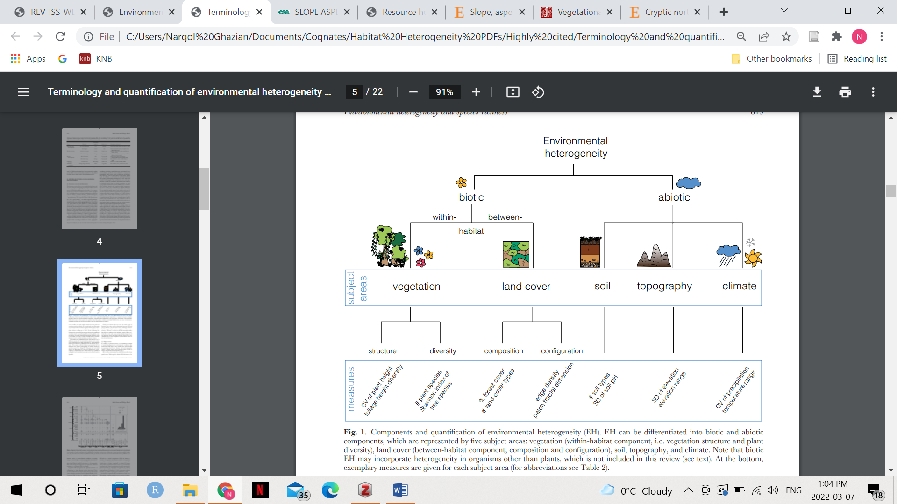The above is an attempt at summarizing the highly diverse topic of environmental heterogeneity. EH has various abiotic and biotic measures because one single measure is simply not enough to provide an accurate representation of this topic (Figure 1). In the following section, I will discuss the effect of organisms on EH and their interactions and response to heterogeneity.

**Figure 1.** Abiotic and biotic components of Environmental Heterogeneity (EH) are shown. Abiotic components include soil, topography, and climate, while biotic components are vegetation and land cover. The most common measure(s) for each component is indicated. From *Stein and Kreft (2015)*.

1. **Environmental heterogeneity and species interactions**

***Effects organism on environmental heterogeneity***

Organisms influence environmental heterogeneity through feeding and physical alteration. Dominant species such as foundation species and ecosystem engineers define spatial patterns on the landscape (Turner and Gardner 2015). Foundation species are organisms that create locally stable conditions through many systematic pathways including abiotic stress amelioration, nutrient cycling, and providing refuge (Filazzola and Lortie 2014). Foundation species are generally locally abundant (Attum and Eason 2006) and alter the abiotic template and resources for populations in the ecosystem. Hence, foundation species assemblage can landscape patterns within communities (Angelini et al. 2011). Loss of foundation species can lead to a cascade whereby species populations and community dynamics are altered. For instance, the drought-induced mortality of the shrub *Juniperus monosperma* has altered vegetation dynamics and resulted in the increase of the invasive species cheatgrass (*Bromus tectorum*) (Kane et al. 2011). Ecosystem engineers are organism that can physically create and modify habitat structures (Wright and Jones 2006). The dam-building beaver (*Castor canadensis*) is the most well-known example of an ecosystem engineer, able to modify habitats by creating dams, which lead to ponds and wetlands (Brazier et al. 2021). They initiate secondary succession when ponds are abandoned and drained, promoting emergent vegetation (Ray, Rebertus, and Ray 2021). Beaver dams also retain large quantities of sediment which would otherwise erode downstream (Turner and Gardner 2015), creating temporally and spatially variable patches leading to plant diversity and hence and increase in environmental heterogeneity (Wright, Jones, and Flecker 2002). Thus, dominant organism can be an important player when it comes to landscape modifications and shaping habitat heterogeneity.

***Effects of trophic cascade on environmental heterogeneity***

Trophic cascades are able to influence spatial patterns through top-down control by a predator. Trophic cascade is a term used for “strong interactions within the food webs that influence the properties of the system,” (Pace et al. 1999). Predators can influence herbivore abundance which can directly affect vegetation patterns. Furthermore, predators can also dictate herbivore presence by creating a “landscape of fear” that causes herbivores to alter their behaviour (Turner and Gardner 2015). Consequently, foraging behaviour of herbivores may change, leading to different landscape pattern through changes in vegetation. In 1995, wolves (*Canis lupus*) were re-introduced to Yellow Stone National Park that triggered the behaviourally-mediated absence of the herbivore elk, allowing woody vegetation to grow taller and canopy cover or stem growth to increase in some locations (Beyer et al. 2007; Ripple and Beschta 2012). Predator-prey dynamics directly and indirectly affect population dynamics and landscape structure. Sometimes, prey need to search for food in high-risk patches where predators are present because there is not enough food otherwise, which drives the predator-prey system in a heterogeneous environment (Laundre, Hernandez, and Ripple 2010). In this case of puma and deer, deer prefer open areas where pumas do not have hiding/stalking advantage. Therefore, the overall outcome of this game depends on the relative amounts and arrangement of safe versus risky habitats. The influence of dominant species and predator pretty dynamics on heterogeneity is an interesting topic as it allows researchers to examine the overlap between behavioural and landscape ecology.

***Effects of environmental heterogeneity on organisms***

Heterogeneity can have strong implications for biodiversity patterns and processes. Understanding these implications is key for management and mitigation of effects of environmental change. In an extensive review, Tscharntke et al. (2012) propose eight hypotheses on the role of landscape composition and configuration on determining “structure of ecological communities, ecosystem functioning, and services” (Table 2). This section is a modest attempt at summarizing the take-away points from the eight hypotheses using insight from Turner and Gardner (2015):

1. ***In general, larger more heterogeneous patches contain mores species and often a greater number of individuals than smaller more homogenous patches of the same habitat.***

Larger patches generally support a more diverse guild of species and this diversity increases as within-path heterogeneity (vertical complexity and microsite variety) augments (Kappes et al. 2009). This is due to the fact that larger patches provide more structural variation in terms of plants and diversity of topography, as well as variability in microclimate. This variability acts as a buffer for populations against fluctuations and provides stability (Oliver et al. 2010).

1. ***The relative abundance of edge and interior habitat affects species diversity within a patch and characteristics of the surrounding landscape affect biodiversity measures.***

Different species prefer either the edge or the centre of the patch due to favouring different conditions. Smaller patches have a greater perimeter to area ratio compared to larger patches that have bigger centres (Fletcher et al. 2007). Patch size and patch shape can influence the proximity of ecotones, defined as shifts between biomes horizontally through space (Neilson 1993), which can result in topographic variability that can affect species occupancy. Characteristics of the surrounding landscape can have a strong influence on predicting local populations. For example, the occupancy of corridors by marsupials in Australia could not only be explained by within-corridor data as information of the surrounding landscape was required (Lindenmayer and Nix 1993).

1. ***Fragmentation negatively and positively influences populations.***

Habitat fragmentation negatively affects biodiversity, including species richness, distribution, abundance, genetic diversity, breeding success, and population growth rate (Fahrig 2003). Fragmentation refers to: 1) breaking apart a given amount of habitat, or 2) changing the configuration of a habitat whilst controlling for the amount (Fahrig 2003). This is distinct from habitat loss that is the reduction in the overall size of a habitat (Fahrig 1997) (Figure 2). Habitat fragmentation can negatively influence by creating extremely small patches where populations cannot be sustained, or increase negative edge effects such as risk of predation (Gates and Gysel 1978). However, fragmentation can also positively influence species by providing extra heterogeneity that may be beneficial to species interactions (Fahrig 2003).

1. ***Landscape connectivity is has profound effects on heterogeneity and hence the local species populations.***

Connectivity refers to how much the landscape aids or impedes movement among resource patches (Tischendorf and Fahrig 2000). Connectivity can be grouped into two categories, including structural connectively, the degree to which landscapes are continuous, and functional connectivity, the degree to which organismal movement occurs (Turner and Gardner 2015). Land-cover changes and fragmentation can reduce functional connectivity by creating inhospitable patches, either through hostile microclimate or increased risk of predation, that organisms cannot get through or purposely avoid (Nowakowski et al. 2013). Hence, reduction in patch size, increased distance between patches, fragmentation, and the combined effects of habitat loss can lead to reduced connectivity.

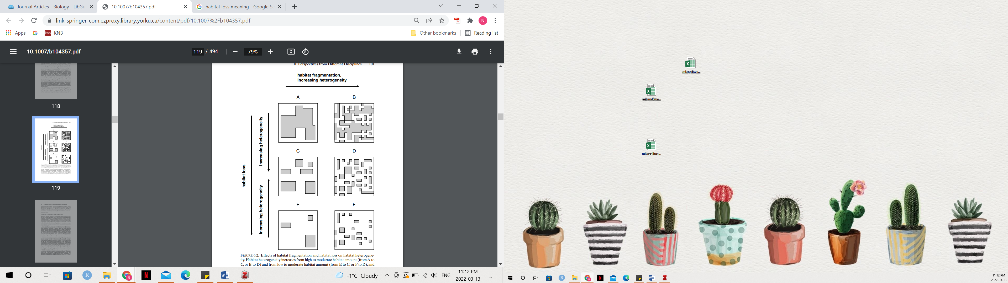

**Figure 2.** Habitat heterogeneity as a result of habitat loss and fragmentation is shown. Habitat loss declines from top to bottom. In each row, habitat amount stays constant but fragmentation increases. From *Lovett et al. 2005*.

Spatial patterns impact heterogeneity and heterogeneity affects species distribution, abundance and survival through a variety of mechanisms. Hence, conservation consideration should take various parameters such as patch size, distance between patches, and the surrounding matrix into consideration when managing for biodiversity.

1. **Disturbance and environmental heterogeneity**

Landscapes are constantly changed by natural disturbances, such as a wildfires and floods, and anthropogenic activities that result in changes in the spatial pattern. Ecosystem process in heterogeneous landscapes can be measured in two ways, including point processes that measure rates at one location, such as rate of primary production, and lateral transfer that is the flow of information, energy, or materials from one location to another in two dimensional space (Figure 3) (Lovett 2005). Disturbance, defined as “any relatively discrete event in time that disrupts ecosystem, community, or population structure and changes resource pools, substrate availability, or the physical environment” (Pickett and White 1985), can be created and sustained by removing materials from one ecosystem and transferring to another ecosystem (Lovett 2005). Natural disturbances are often an integral component of community structure and ecosystem function (Collins 2000). Heterogeneity in ecosystems can influence disturbance regimes by 1) providing susceptibility to a particular disturbance, or 2) providing a configuration that affects how disturbance spreads (Turner and Gardner 2015). Factors such as topography, nearby vegetation, and microclimate can impact the frequency and severity of wildfires (Romme 2005). For instance, areas of rugged topography, such as cliffs, burn less often because steeper slopes inhibit the spread of fire and create more (Romme 2005). However, this effect of topography on fire can vary with climate with moist valley bottoms burning less frequently than adjacent drier slopes (Romme and Knight 1981). Whether configuration spreads or hinders the spread of disturbance differs amongst disturbance types. For example, fragmentation and clearing of boreal mixedwood forest enhanced the outbreak of the forest tent caterpillar (*Malacosoma disstria*) because it decreased the interaction of the caterpillar and its predator (Cooke, MacQuarrie, and Lorenzetti 2012). On the contrary, the extensive logging and previous fires resulted in landscape heterogeneity and decreased conifer densities in Southern Rocky Mountains retarded the spread of the western spruce budworms (*Choristoneura occcidentalis*) (Swetnam and Lynch 1993). Generally-speaking, if disturbance is spread between the same cover type, then increased heterogeneity slows the spread of disturbance but when disturbance occurs between cover types, edge effects or increase heterogeneity should enhance the spread of disturbance; though, the concepts of thresholds is also important to consider.

***Anthropogenic activities and disturbance***

Disturbance can create complex patterns of different severities across the landscape. This is referred to as a “disturbance mosaic” that is the spatial patterns created via disturbance (Turner and Gardner 2015). Landscape patterns can be generated by human activities. Anthropogenic climate change for example leads to nitrogen deposition, phosphorous inputs and alteration of rainfall patterns, which results in the heterogeneous distribution patterns and increased biological invasion (Wang et al. 2021). Land conversion for human activities including agriculture and urbanization can lead to fragmentation, creating new edges and microclimates, which may significantly change the native plant and animal communities present (Collinge 1996). However, disturbance resulting from human activities may also prove to be beneficial.

1. **Incorporating heterogeneity into research**
2. **Conclusion**

in